# General description

The main controls of EEB are the drawing and the data table. Both got their own functions to show specific objects. The wording for these functions is as follows:

1. In drawing objects are **highlighted**, which means the color of the objects is set to magenta.
2. In data tables objects are **selected**. Like in standard windows look and feel the selected objects (rows) have a blue background and white font.
3. In data tables objects can also be **marked**. Marked objects have a light green background and black font.

## Highlighted objects

Objects are highlighted in the drawing by clicking on them or by dragging a border around them. When an object gets highlighted in the drawing it gets selected in the data table and the tab of the data table changes to the corresponding category. The previous selection gets cleared. If a border is dragged for multiselection of objects in the drawing, the tab of data table isn’t changed and only objects on the current tab are highlighted. Also the previous selection gets cleared.

If module configuration is change, the highlighting gets cleared.

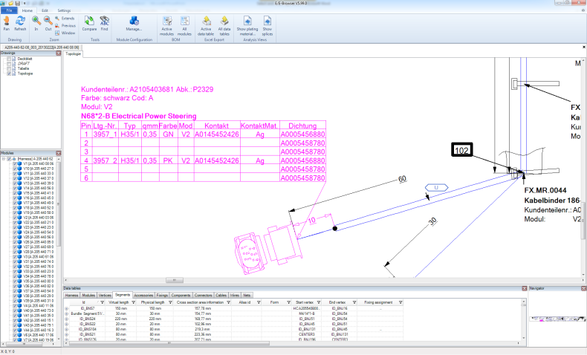

Abbildung 1: Highlighted object

Conclusion:

* Dragging border for multiselection
* Highlighted objects get slected in data table if possible (see text for further explanation)
* Change of module configuration clears highlighted objects

Changes compared to EEB 5.99.0.202:

* No changes

## Selected objects

Objects get selected when they are clicked in the data table. As soon as an object is selected it will be highlighted in the drawing. All objects that are not selected will lose their highlight. Multiselection of objects is possible and can be done by using shift-key, control-key or dragging over several objects while holding the left mouse button.

If module configuration is change, the selection gets cleared. But the selection is not cleared when tab is changed and therefore highlighted objects are also not cleared. They get cleared as soon as an object is selected in the new tab, no matter if multiselection keys are used.

Selected objects are sorted to the top of the table, if a tab is changed or if a sorter is trigger by the user (press table header). The sorter is not triggered automatically.

The selection is cleared when esc-key is pressed while data table has the focus.

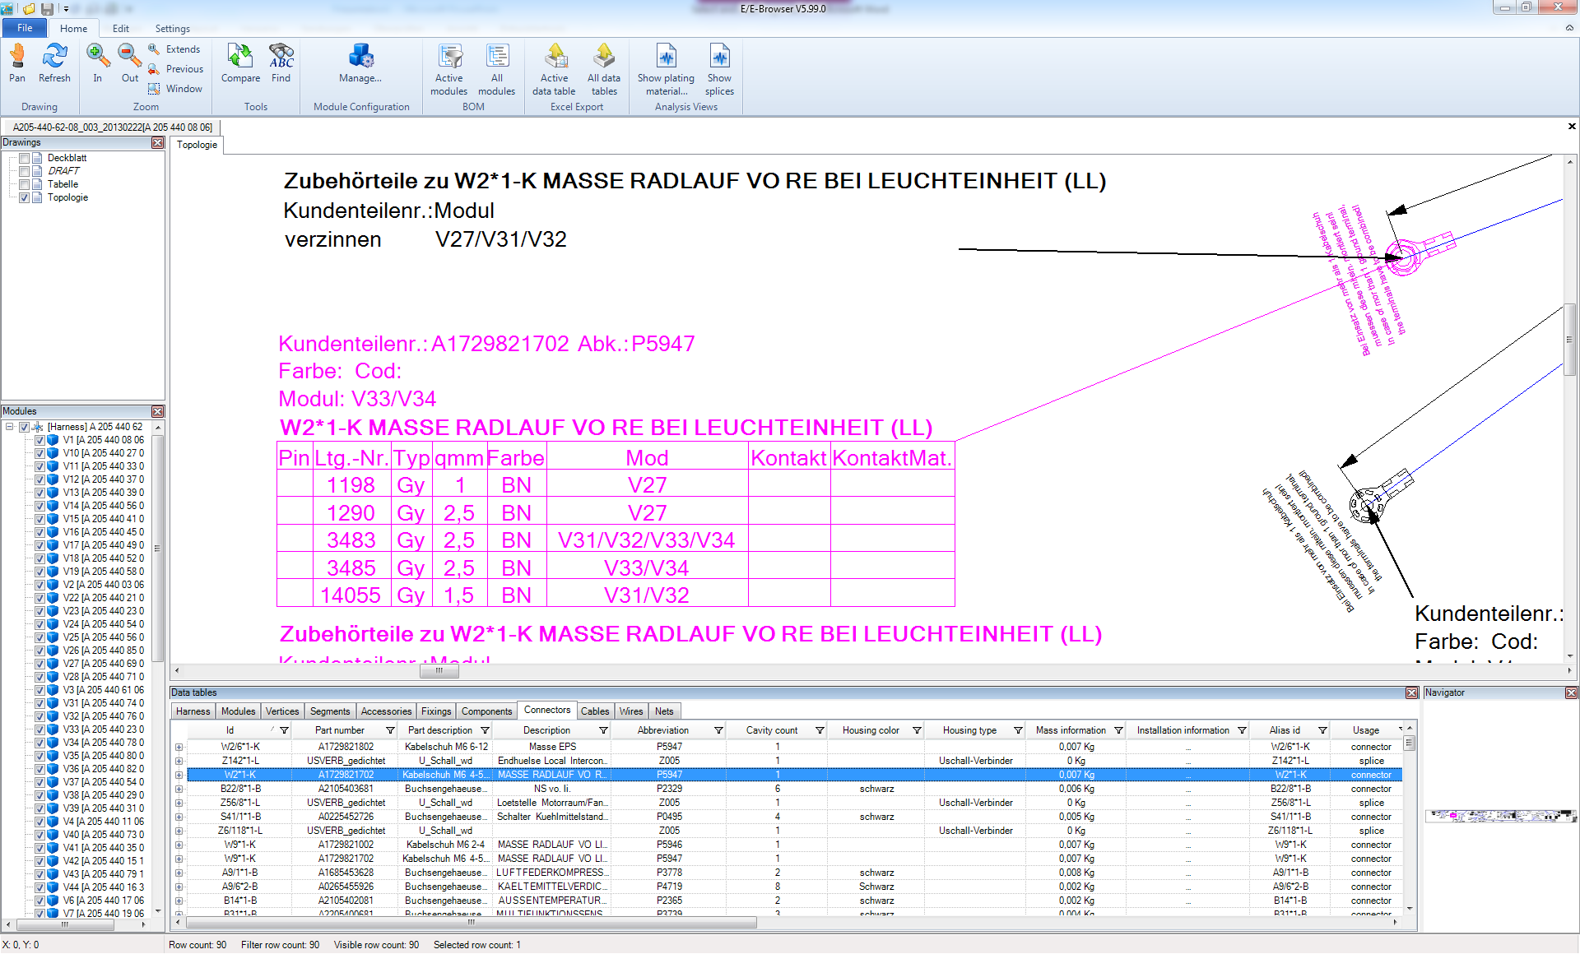

Abbildung 2: Selected object

Conclusion:

* Exactly like known from windows explorer
* Shift- and control-key for multiselection
* Dragging with pressed left mouse button for multiselection
* Selected objects get highlighted in drawing
* Change of module configuration clears selection
* Selection is not cleared when tab is changed
* Esc-key clears selection
* Are sorted to top of table

Changes compared to EEB 5.99.0.202:

* What is now magenta (fixed) in the data table will be selected in future. In future ther will be no magenta, all selected object have to be blue (windows look and feel)
* Selection is not cleared when tab is changed
* Esc-key clears selection

## Marked objects

Marking objects helps users to keep an eye on the connections between objects. A user can chose any object and set it as **origin for marked objects.** There can also be several objects as origin, but they will always be from the same object category. EEB keeps the list of origins until it is cleared by the user or new origin(s) are set. Marked objects are not highlighted in the drawing.

Every time a user changes the tab in the data table, EEB calculates the marked objects based on the current origins. When the origins are cleared, all marked objects are cleared.

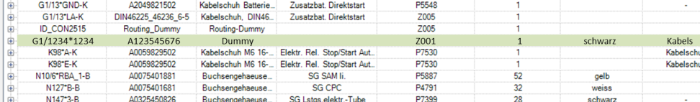

Abbildung 3: Marked object

The origins of marked objects are shown with light green background and black bold font.

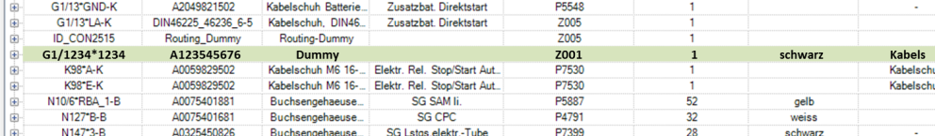

Abbildung 4: Origin for marked objects

Origins are set by context menu in the data table. User can also set an origin rapidly by double clicking it. They are cleared in the same context menu. They can also be cleared by pressing esc-key, if:

1. Data table has focus
2. No object is selected

If mark origin objects are cleared the data table needs to be updated instandly.

Objects that are marked or an origin can also be selected. Than they will be shown as selected objects (see 1.2).

Marked objects are sorted to the top of the table together with selected objects, if a tab is changed or if a sorter is trigger by the user (press table header). The sorter is not triggered automatically. Be sorted together with selected objects meens, all marked and selected objects are merged to one list for the sorter and this list is sorted to the top. So the table can start with a selected object, then they could be several marked objects, then again some selected objects and so on. All sorted by the current criteria. Not till then the normal (not marked, not selected) are shown.

Every time the module configuration is changed, the mark origin objects are cleared and thus the marked objects are cleared as well.

Conclusion:

* Marked objects have a connection to a mark origin object
* Mark origin object(s) are set by user by using context menu or double clicking an object
* Mark origin object(s) are not changed until:
  + the user clears the origins, by using context menu or pressing esc (see text)
  + the user selects another origin object(s)
* Marked objects are not highlighted in the drawing
* Marked objects can be selected
* Marked objects are recalculated every time a tab is changed, based on the origin objects
* Marked objects and origin objects are cleared if module configuration is changed
* Are sorted to top of table together with selected objects

Changes compared to EEB 5.99.0.202:

* Completely new

# User Interface

## Changes in data table

There are extensions to the data table context menu:

* “Mark corresponding objects”: sets the current selection as mark origin object(s)
* “Clear marks”: clears the current origin object(s)
* “Select marked objects”: Selects all marked objects

# User input

To improve usability and logic user can control selection with single left mouse click and single esc-key stroke. He can also control the mark origin objects by double clicking mouse button and “double” esc-key stroke

Left mouse click on data table object:

* Selects object (like it is today, no change here)

Double left mouse click on data table object:

* Selects the object as mark origin object

Esc-key clears selection if (will normally feel like single esc-key stroke):

* Data table has focus
* There is a selection

Esc-key clears mark origin objects if (will normally feel like double esc-key stroke):

* Data table has focus
* There are no selected objects
* There are mark origin objects